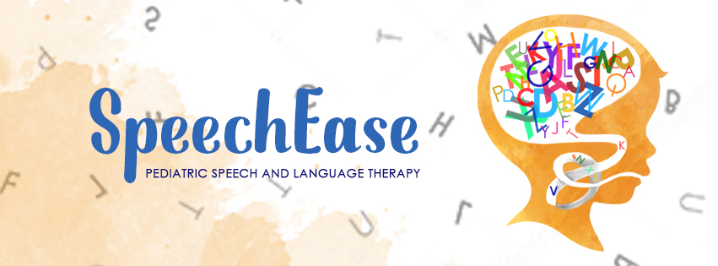
2020-2021 Calendar
SpeechEase, PLLC generally follows the academic calendar of the Frankfort School District, 157c.
Dates on which SpeechEase, PLLC will be closed include:

October 8-9, 2020 (Columbus Day Weekend)
November 26, 2020 (Thanksgiving Holiday)
December 21-25, 2020 (Week of Christmas)
March 29- April 2, 2021 (Spring Break)

Summer Intensive weeks:
June 21-25, 2021
July 2021 TBD
August 9-13, 2021

